**PCB Design**

The PCB design of flyback converter are divided into three parts. These are the controller part, primary side, and secondary side. Since the flyback is an isolated converter, the ground of primary and secondary must be separated. The ground of the controller is connected to primary side of the converter.

The initial schematics of the converter can be seen in Figure 1. To decrease the complexity of the circuit, voltage protection of optocoupler is design with only Zener diode. The input and output capacitors are divided into different capacitor values to eliminate noises at different frequencies. There are capacitors at the Vcc pin of the IC to clear noises at the supply voltage of it.

Figure 1 Initial Schematic of Flyback Converter

Top and bottom layer of PCB can be seen in Figure 2 and Figure 3 respectively. As can be seen in Figure 2, controller circuit is placed left side of the PCB. The components are placed as close as possible. The switching node is also drawn as small as possible to decrease stray inductances since the switching frequency is high. The near of optocoupler, protection and feedback circuit are placed. Feedback line at primary side and anode pin of optocoupler is drawn at bottom since there is not enough place.

Figure 2. Front Side of Flyback Converter PCB

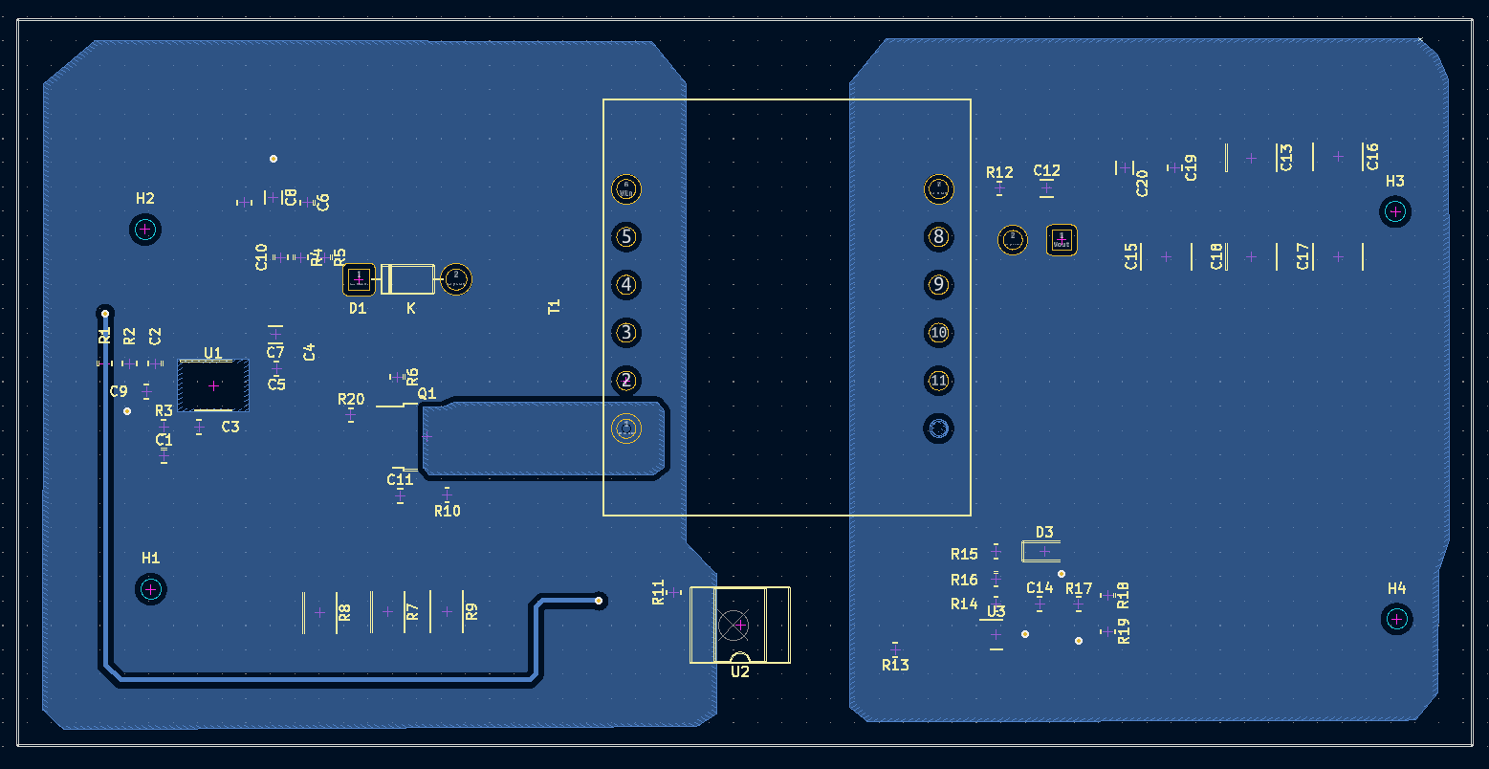

Figure 3. Back Side of Flyback Converter PCB

After experimental tests of the circuit, PCB is updated with some jumpers since there is no time to produce again. Firstly, just upper side of optocoupler, at secondary side, the protection circuit with BJT is placed again. Current sense connection is completed with 1kΩ through hole resistance to filter current sense output. To compensate inrush current at the beginning of transient, a higher value electrolytic capacitor added at the input. The value of it is 2.2mF 50V. Finally, to decrease output ripple, two electrolytic capacitors, 470uF and 330uF are added at the output of the circuit. The final circuit can be seen in Figure 4. The input capacitor is added after this photo is taken.

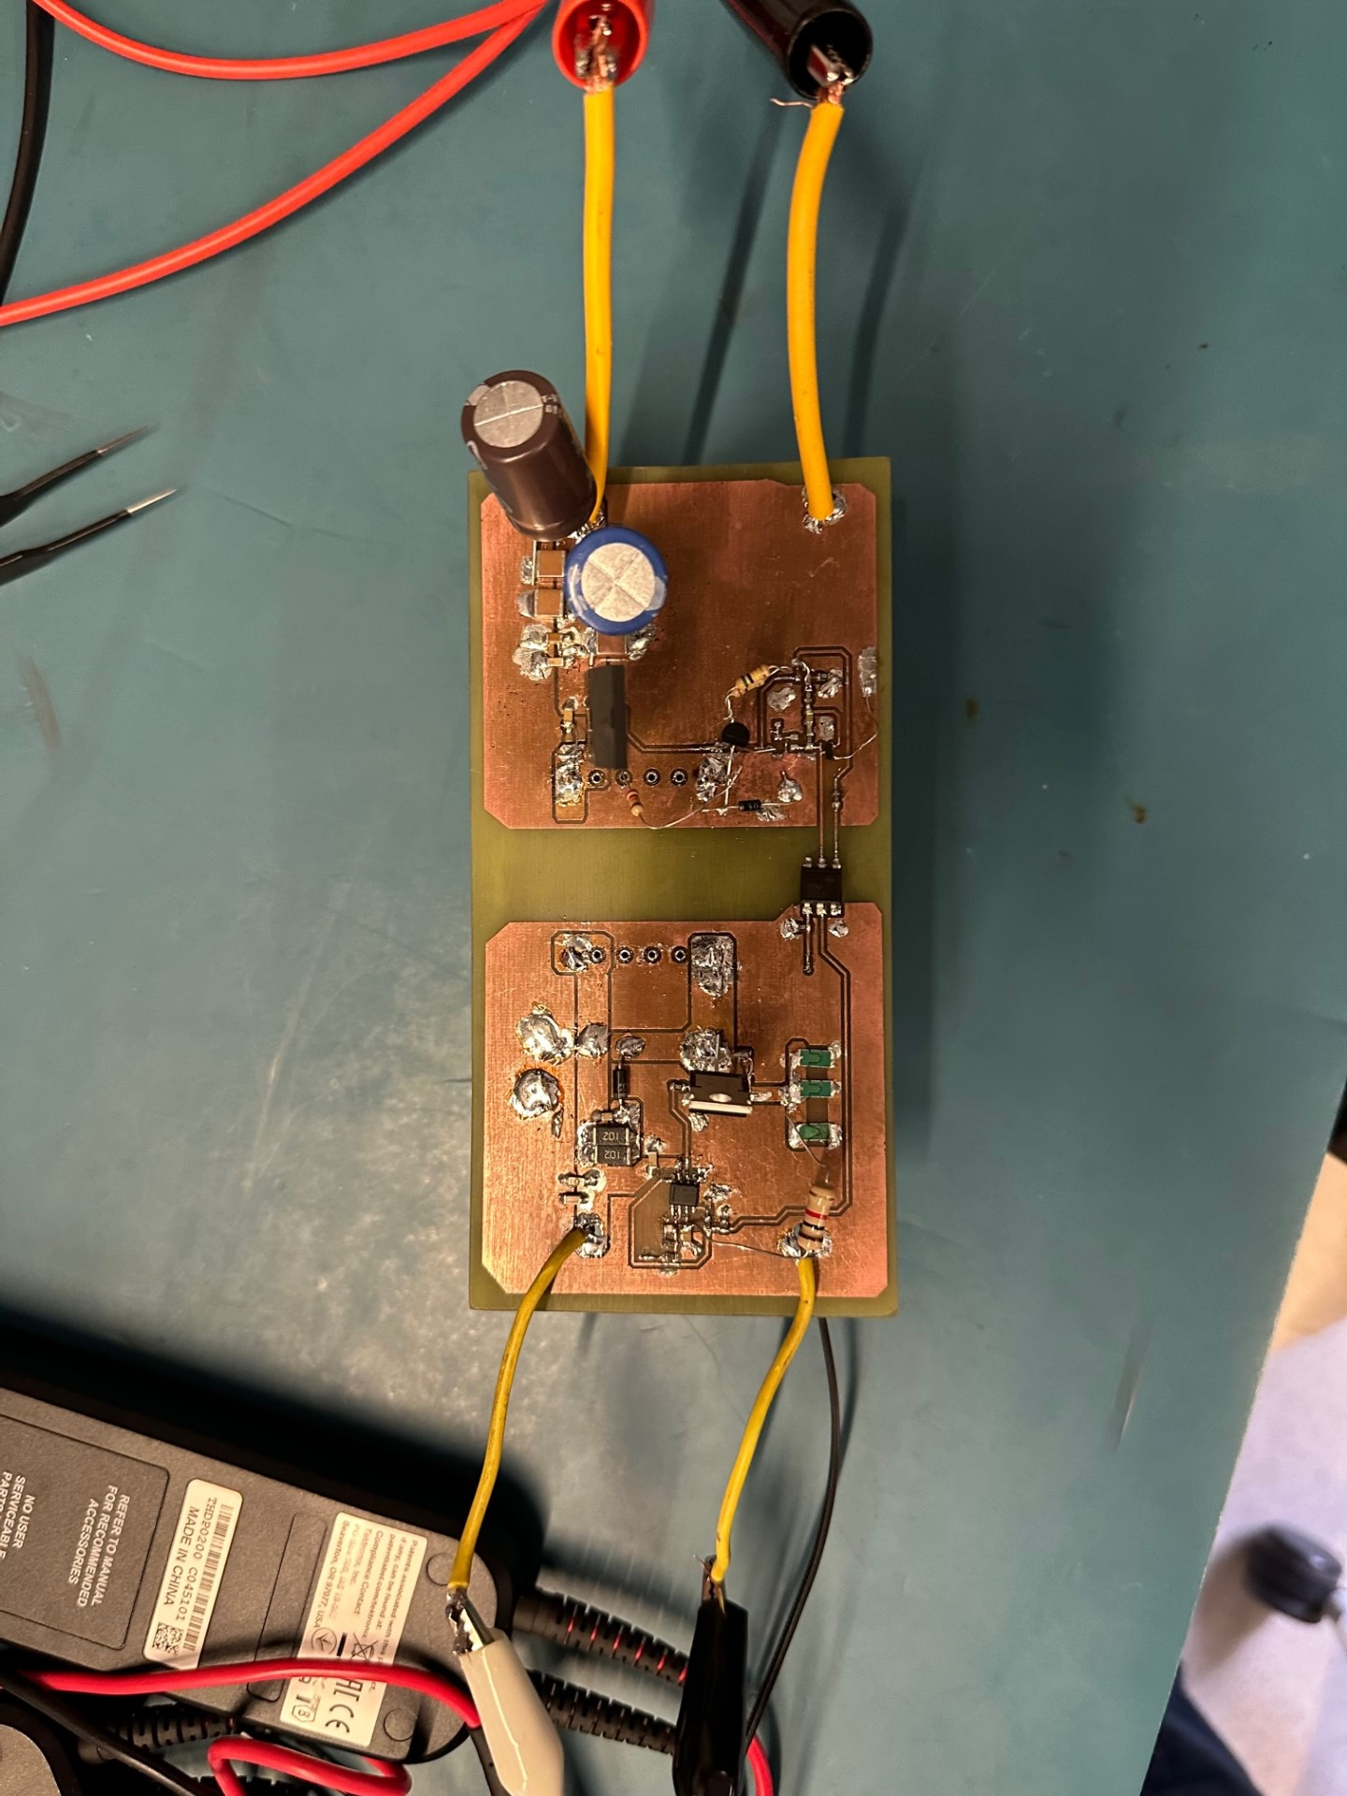

Figure 4. Final PCB Design